Let's Talk About...Mental and Spiritual l Health

.
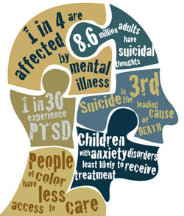
Are you struggling with stress, too many expectations or responsibilities? Have questions, doubts, or concerns about your faith? Come and join us for
A Discernment Circle
“Calling, Conflict, and Self-Care”
October 19, 2017
4:30-5:30 pm in K114
Lisa Banks-Williams
Program Coordinator for Student Care
Chaplain Joey Heath-Mason
Kay Spiritual Center, American University

Sponsored by the Office of Community Life- Wesley Theological Seminary.

