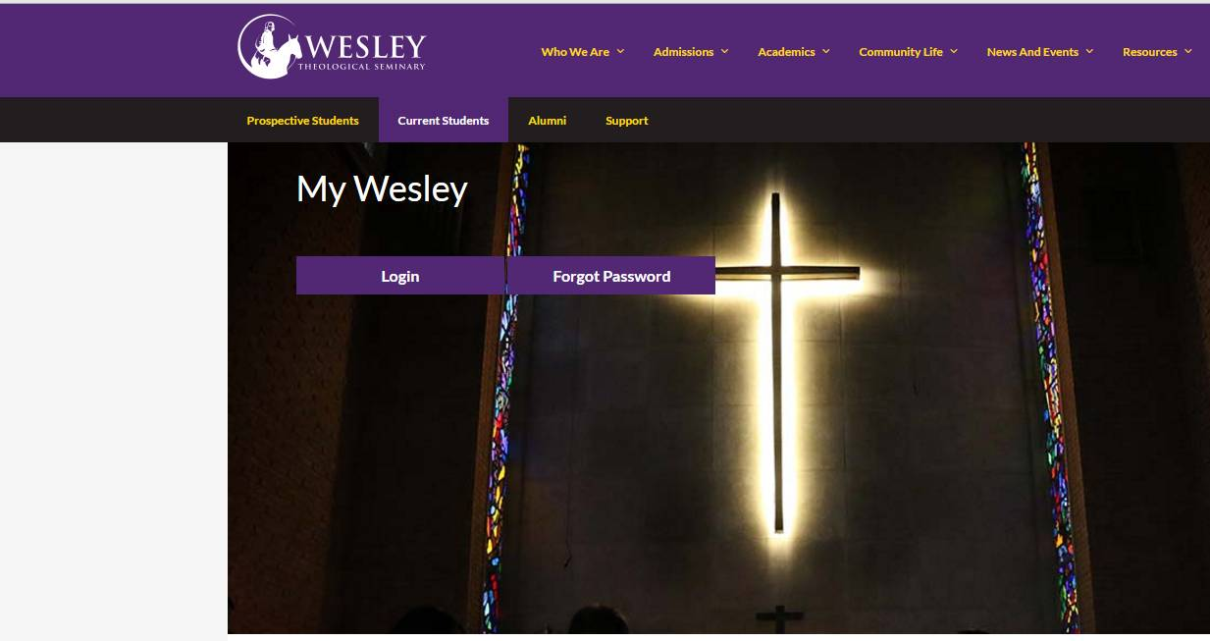

Click on Login

Click on WesleyWeb

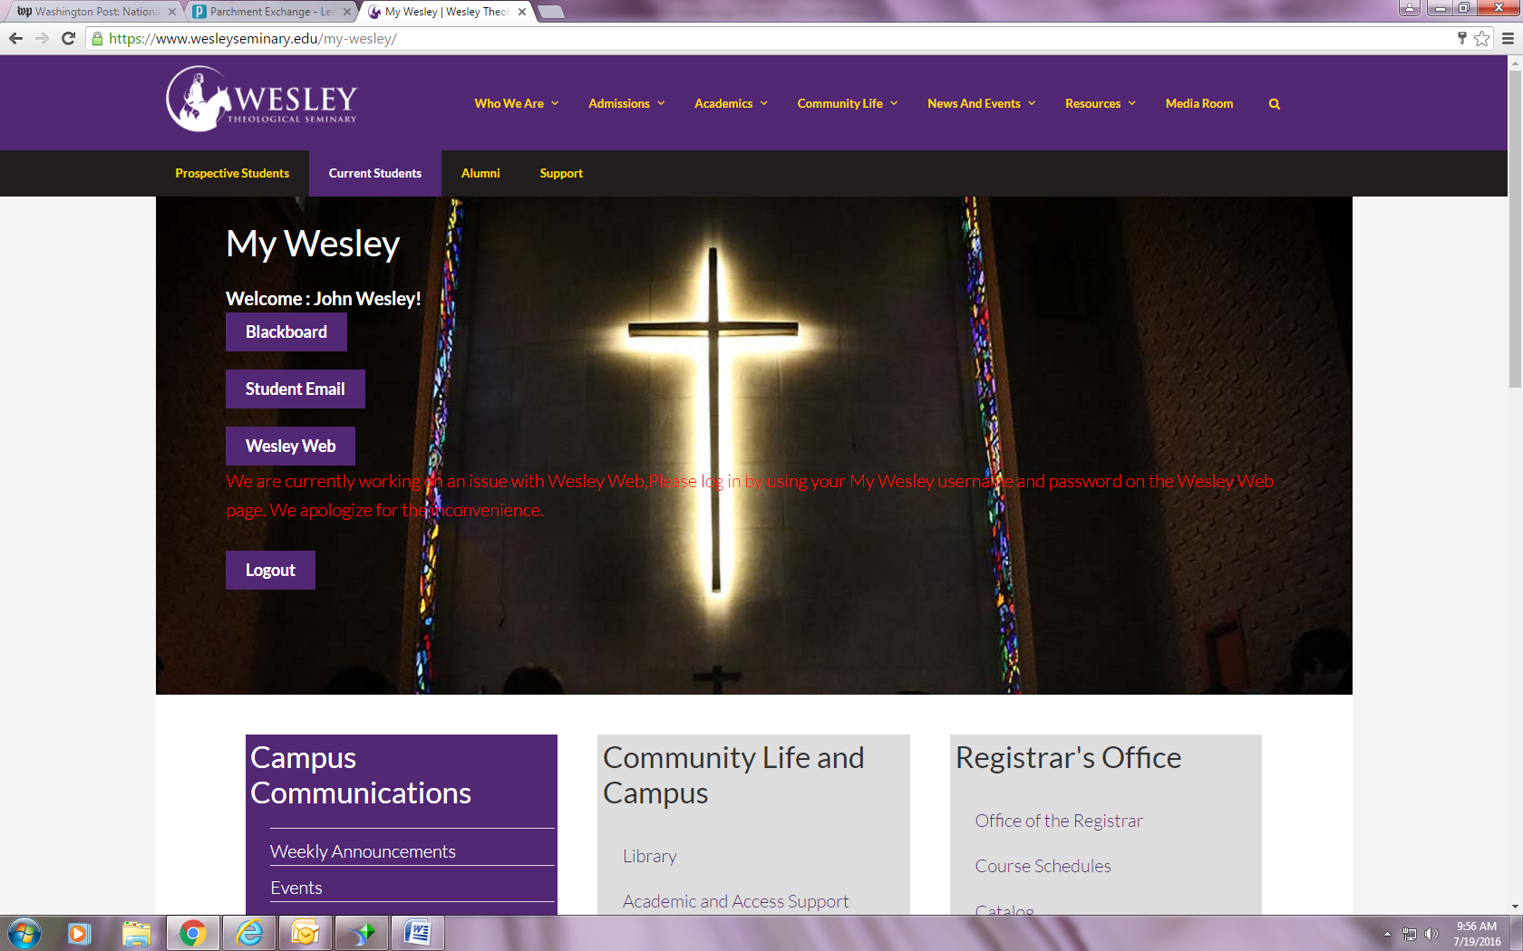

Click on WesleyWeb

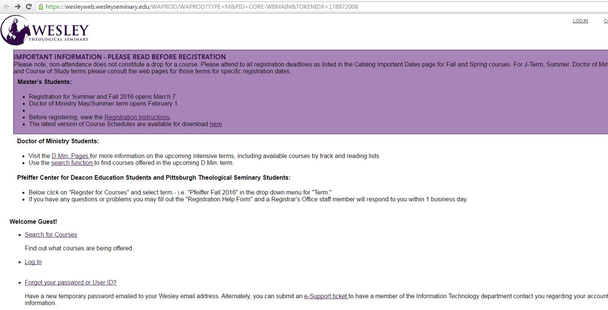

Click on Log In again

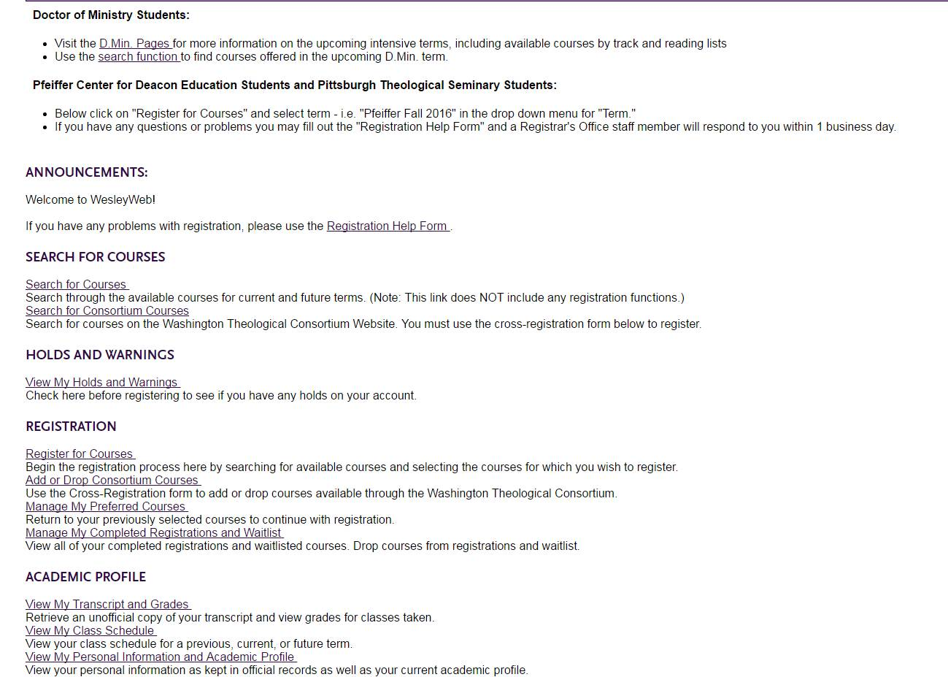

Click on Register for Courses

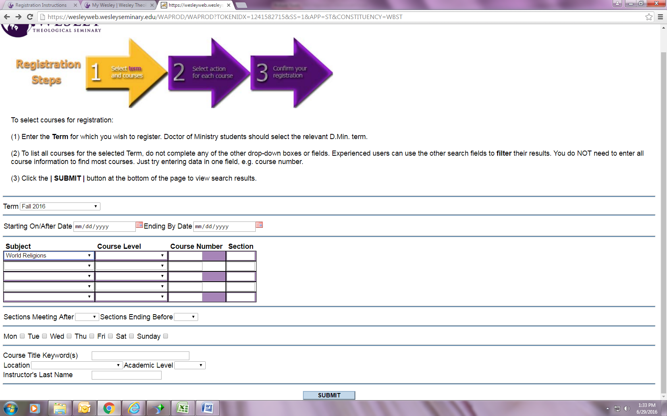

Click on Submit

Select the appropriate term from the pull down menu.

Select the appropriate subject from the pull down menu and scroll down to hit submit.

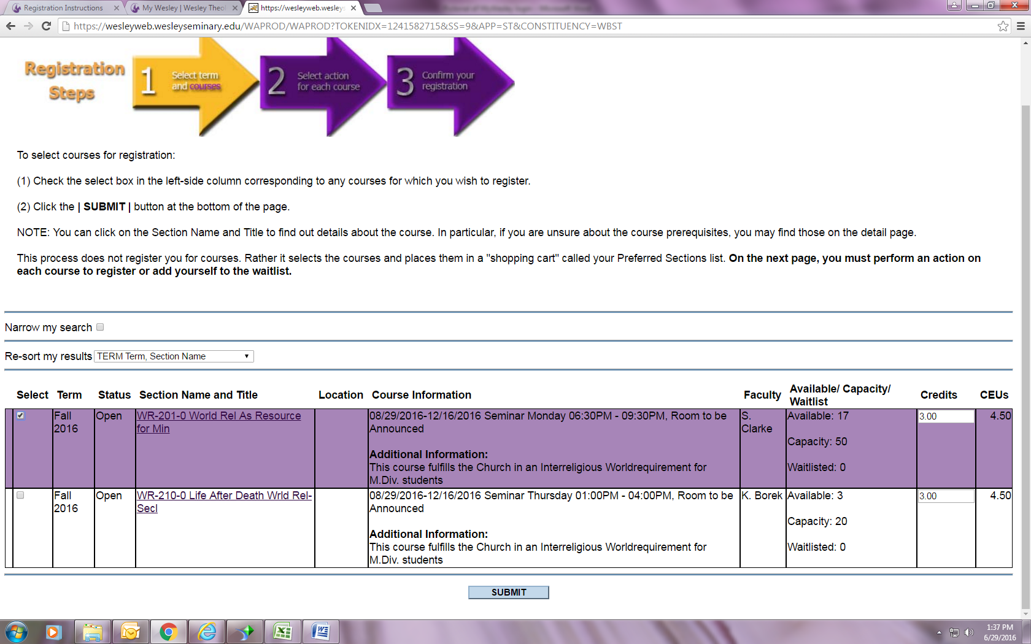

Review the dates of the class and the instructor to ensure this is the correct class and check the box. Hit submit.

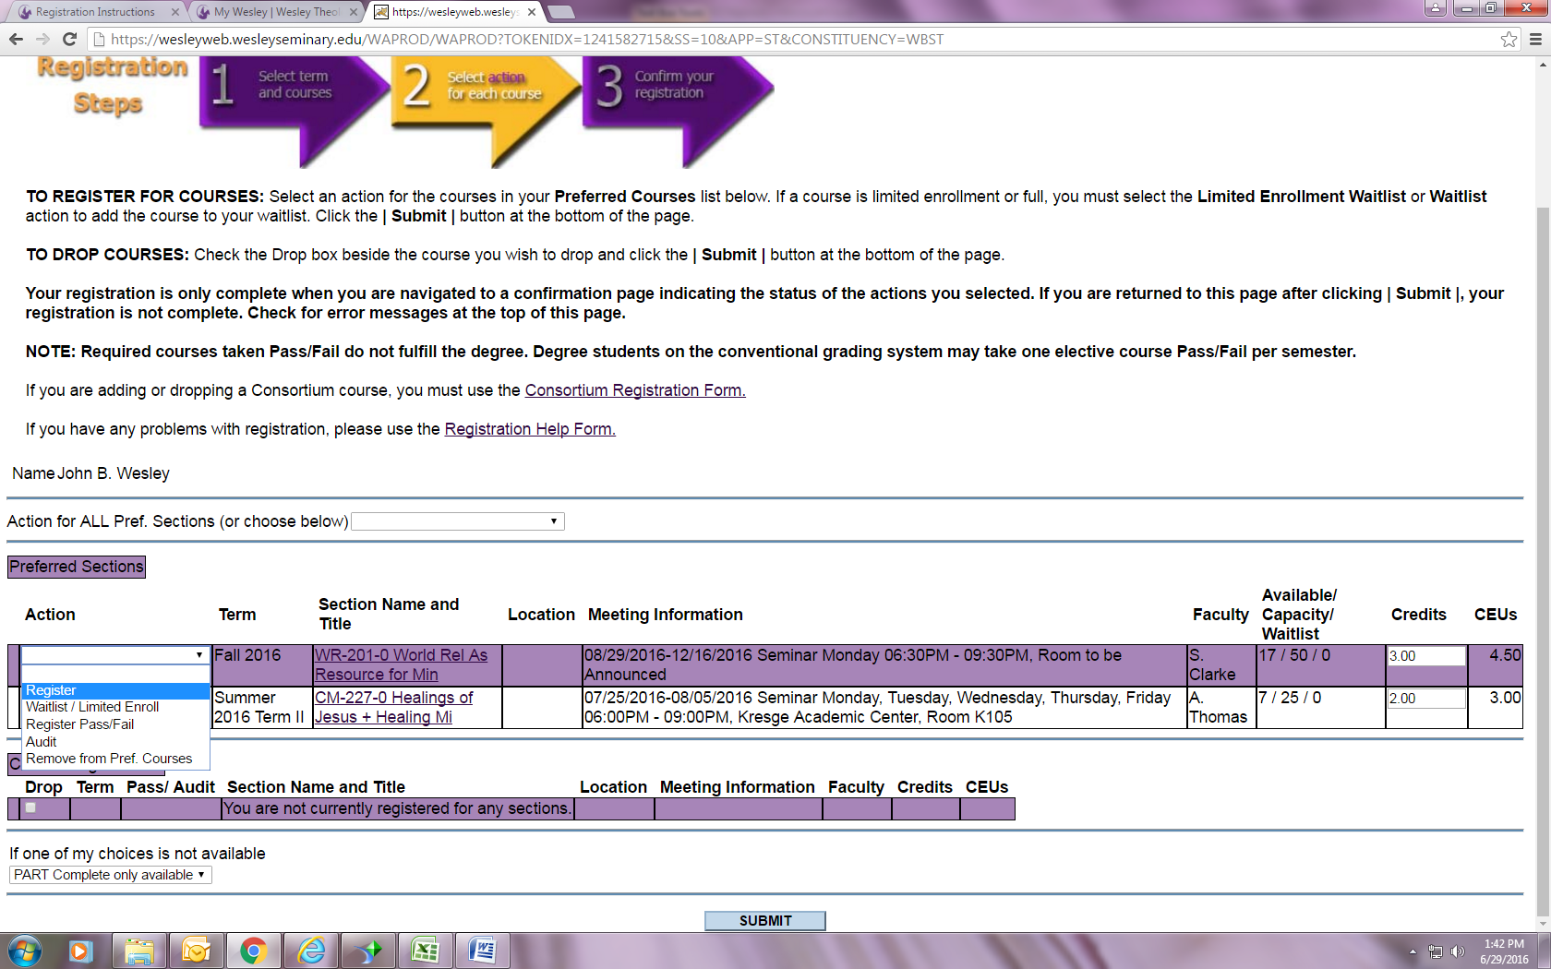

From the drop down menu, select REGISTER, WAITLIST, REGISTER PASS/FAIL, AUDIT, OR REMOVE FROM PREF COURSES before you hit the submit button*.*